This Project Tracking database allows FETP residents and staff to track the progress of all projects initiated by residents until completion. It is a relational database. The principal, parent, database is the **Project**. Several child databases show the **residents assigned to the project**, the types of **communication products**, and the public health actions derived from the project. Two other related databases maintain rosters of residents and graduates and of consultants (mentors and supervisors).

Project tracking is designed so that the FETP resident can enter and update projects remotely through email or the internet. Project data may also be updated and corrected from the FETP office. In addition, data may be entered, updated, and analyzed directly from Epi Info installed on a computer. This tracking database is centered on the **Project,** the parent database. The residents assigned the project, communications of all types that arise from the project, and the end results of the project are linked and will be completed as data are entered into the project.

**Opening page**

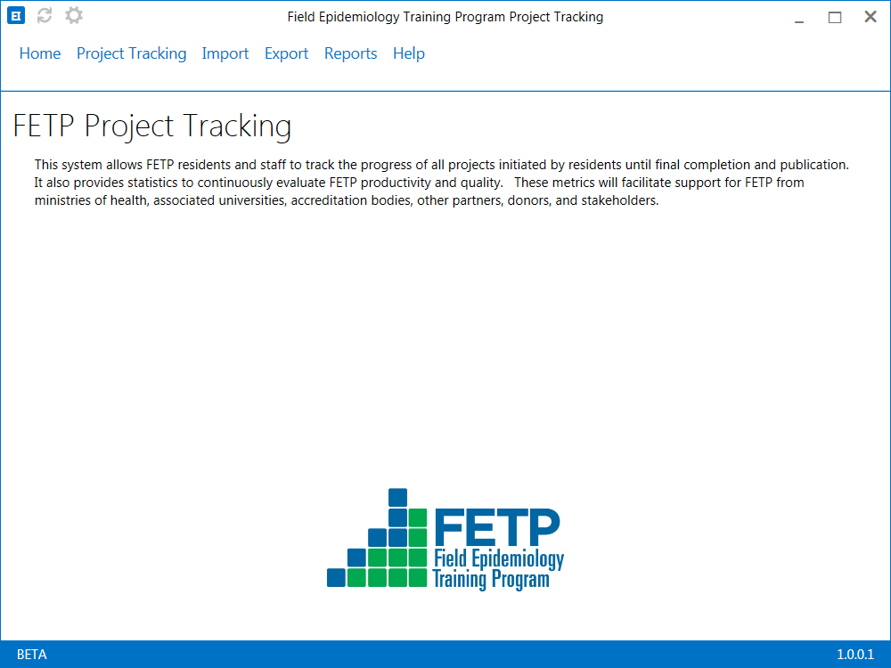

**Preliminaries**

Before you first enter data on projects you will need to complete three preliminary tasks. These include revising a legal value pick list for your program’s field sites, adding resident information, and adding consultant (mentor or supervisor) information to two forms. For the 2017 data call you must enter information for all residents who had projects in 2017. Without this resident information you cannot enter projects in the main “Project” form. The main “Project” form accesses this resident information to create a list of current residents to select from. We will also use these data to tabulate information on your residents. If you have time, we recommend that you to enter all residents that have ever been in your FETP. This will save you time later in back entering old data for future analyses. To begin click on the gear Icon at the top left hand corner of the cover-page of the Project Tracking program. You will be given a choice of the “Resident Information” or “Consultant information”. Select and open “Resident Information”.



Task 1: Edit the legal values for the Field Sites.

**Form: Initial Project Data**

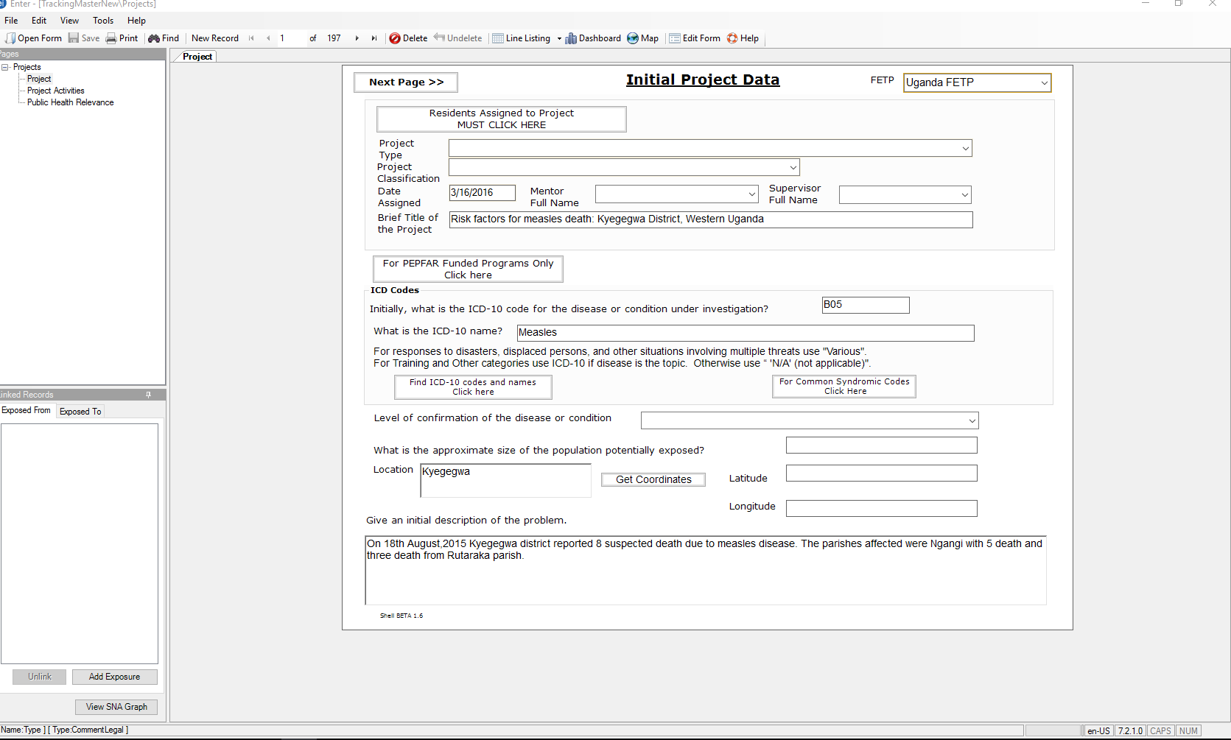

This first page of the project record contains information necessary to initially register a project. Enter these data when the project is assigned. If more than one resident is assigned to the project, a specific resident will be designated the **Lead** on the project. The **Lead** resident will be responsible for entry of most data on the project including the names of other residents on the same project (**Team Members**).

**If you are not the lead resident on the project, do not continue or enter data now.** The **Lead** resident will do this. Later, once the project is registered in this database, the **Lead** and all **Team Members** will be able to see all information about the project and add details specific to any individual contributions. Usually, information that you add later as a **Team Member** will be about communication products for which you are the first author.

**Sequential listing and instructions for Initial Project Data.** Questions, prompts, and buttons are in *underlined Italics.* Responses are **bolded.**

*FETP:* For the first project select your FETP from the drop down list of all FETPs. Once filled for the first time the selected FETP autofills for subsequent projects. This is a “must enter**”** field.

*Residents Assigned to Project (Button):*Clicking this button will take you to a form that provides a picklist of the names (Surname, Given name) of the current residents from the resident database. Under *Resident Name* Scroll down the picklist and select your name. Then under *Resident role on project* select **Lead**.

If other residents are also working on the same project and you are the **Lead,** click the *Add Resident* button to open a blank form, pick the second *Resident name* and under *Resident Role on Project* give that resident the role of **Team member.** For more residents just repeat this process designating each additional resident as a **Team member**.

When you finish entering all residents assigned to the project, “*Save and return to project*” button to return to the main project form.

*Project Type:* These are in the drop-down picklist. These project types are also defined in appendix B. For projects or assignments that do not appear in the drop down list. Use **60-Other project type not listed** or **61-Other, wrote publication that was not derived from an existing project**. These unclassified assignments may actually be compatible with field epidemiology training, and in that sense will reflect your overall competence achieved at the end of the training. The leading digit of the code numbers associated with each project type (e.g. the 4 in 40) corresponds with the leading digit of the next variable, *Project Classification*.

*Project Classification***:** Use the project classification thatcorresponds to the leading digit of the project type. For example of the project type is 13 then select **10 – Emergency Investigation** for the *Project Classification*. *Project Classifications* are defined in appendix B.

*Date Assigned:*Enter here the date of assigning the project. Some projects for some reason may later be suspended. Nevertheless, they need to be recorded to help FETP management to avoid future situations leading to suspended projects.

*Mentor full name* and *Supervisor full name***:** Select from the dropdown list in each. These lists are the same for mentors and supervisors. You may enter the same name in both variables when the mentor and the supervisor are the same person. Use definitions of mentor and supervisor established for your FETP.

*Brief Title of the Project:* This is a free text variable. Compose a brief title that fits within the space provided.

*For PEPFAR Funded Programs Only Click Here (Button):* If this is a PEPFAR Funded FETP, your FETP Office will complete these data. For instructions, see Appendix C.

*ICD-10 code* and *ICD 10 Name*: These two fields are filled by accessing the WHO ICD-10 website. One can include a disease or condition or group of diseases or conditions even for project classifications as **training** or **other**. When a project involves multiple diseases or conditions (e.g. general health protection at a mass gathering) use the term **Various** in both the *ICD-10 code* and *ICD-10 Name***.** Use **Not Applicable** for both if the project does not involve diseases or unhealthy conditions.

Clicking the *Find ICD-10 code and names* (Button) will take you to the WHO ICD-10 website. Type the disease name into search box to see the possible ICD-10 codes and ICD-10 names. Select the best fit to the situation. Copy your selection for the ICD-10 code and the ICD-10 Name and paste them into the fields for the *ICD-10 code* and the *ICD-10 name*. For some common syndromes for example severe acute respiratory infection (SARI) we have provided a *For Common Syndromic Codes (Button)* with a listing some common broad syndromes and the ICD 10 codes to use for them. Use copy and paste to enter ICD-10 data to avoid typographical errors, which will complicate data management and analysis.

Use the broadest ICD-10 code available that includes all of the possible cases of the disease that you are dealing with. For example, pneumonia will bring up many codes by organism, organism groups, secondary pneumonias, etc. Often we deal with pneumonia but do not know the causative organism. For this will find the ICD-10 code **J18** and ICD-10 name **Pneumonia, organism unspecified**. You will have another chance to enter more specific names revealed by your investigation on the second page “Project Activities”

*Level of Confirmation of the Disease or Condition:* You have three choices. **All cases are confirmed**. This may arise if you are using confirmed cases from the laboratory or registry or for conditions such as injuries which are obvious by initial clinical observation and history. **A sample of cases are confirmed**. This may happen for example on an outbreak when resources are not available to confirm more than a sample of cases. **No cases are confirmed.** This could happen on an outbreak of acute respiratory disease where no laboratory support is available. As with the ICD 10 code, you will later have a chance to show a new level of confirmation that results from your investigation on the second page “Project Activities”

**Approximate Size of the Population Affected:** Use the size of the population which best encompasses the geographic boundaries of the investigation. If it is an elementary school, use the elementary school enrollment. If it is a village, use the village population. If cases are widely scattered throughout the city use the entire city population. Similarly, if cases are scattered throughout a province or country use the country or province population.

**Location**: Type in the name of the population unit with the state or province and country covered by the project. Then click on “**Get Coordinates**”. You need to be connected to the Internet. The program will then access the Epi Info mapping module and autofill longitude and latitude. If dealing with a larger areas such as a county, city, province, or country the coordinates will represent the center point of that administrative unit. If you type in a name that is not recognized you will get an error message. Then you can try another spelling, an alternate name, searching another free online mapping program, or find the next largest administrative area that contains your location. If you travel to the location for the investigation you can get the coordinates directly with a smart phone or another GPS device.

*Give an initial Description of the Problem:* This is a freeform text variable to provide key details not already covered. Give some reason why this problem is important plus the purpose and objectives of the project. You may also provide other key issues and explanation. You do not need to repeat the information about the disease, time, place, person, that you of already provided above.

**Form: Project Activities**

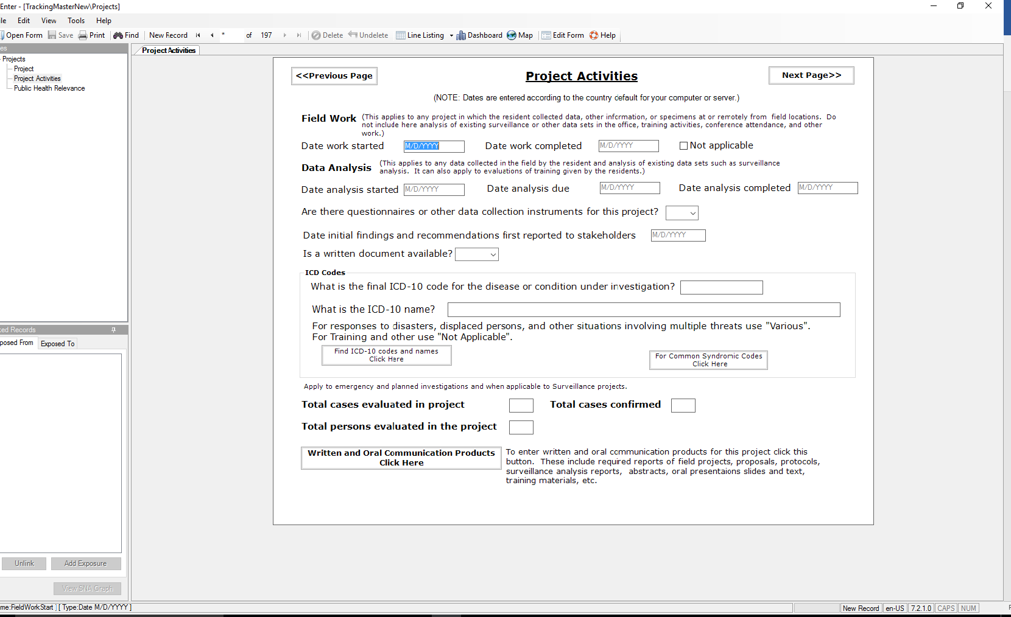

This second page of the Project Database record documents key dates and activities completed during the life of the project.

*Field Work:*See the instructions at the prompt.These dates apply to any project that involves visits to the field to gather data or information. Also, includes telephone, mail, internet, and other remote methods for surveys, questionnaires, interviews, and other data gathering.

*Data Analysis:* See the instructions at the prompt.This includes all analysis generated from the previous variable (Field Work), existing data sets, and evaluations of training.

*Are there questionnaires …*: Select **Yes** or **No**. It is recommended that these be provided to the FETP Office and maintained on file there.*Date initial findings and recommendations…*: Enter the date

*Is a written document available?* : Select **Yes** or **No**. Written documents include electronic files, slide presentations, speaker’s notes, talking points, graphs or tables to hand out, existing standard recommendations, and any other information related to the project. It is recommended to provide these materials to the FETP Office and maintained on file.

*ICD 10 Codes:*These data are auto-filled from the ICD-10 information on *Page 1.* If findings from the investigation have changed or refined the diagnosis, you should change these auto-filled values to the new and improved values. Do not return to page 1 and change the originals.

*Total cases evaluated*: Give the number of cases that the investigation team reviewed, interviewed or otherwise evaluated.

*Total cases confirmed***:** Give the number of confirmed cases.

*Total persons evaluated*: Give the total persons evaluated including case finding, cases, non-cases.

*Written and oral communication products***:** Clicking this button will take you to a form to enter proposals, protocols, field reports, and all other written or oral communication products resulting from this project. Multiple documents of different types may be entered. Use a new record for each communication product.

*Resident responsible for the communication product:* Select your name from the picklist if you are the resident responsible (first author) for preparing this specific communication product. If another **team member** or **Lead** is responsible for this communication product, stop entering data now and click on the “Return to Projects” button.

*Resident ID*: This is reserved for later versions of the project tracking program. Do not enter.

*Resident position on project*: If you are the **Lead** on the project, select **Lead** here. If your are a **Team Member** on the project not then select **Team Member**. The **Lead** will be responsible for the proposal, protocol, basic field report, or surveillance analysis report.

*Type of communication project:*Select the type of communication product from the drop down list.

Digit 1 Code Beginning: Commonly required reports in FETPs.

Digit 2 Code Beginning: Scientific works for presentation and publication.

Digit 3 Code Beginning: Informational materials meant for the public, stakeholders, other health workers, etc.

Digit 4 Code Beginning: Involve training materials and reports about training.

*Is this a required communication project?*Select **yes** or **no** depending on the requirements of your FETP. If you have exceeded the minimum required number of particular type of report also answer **yes** (it is required).

*Drafts:* To register completion of a communication product, enter the date of completion in the top cell of the *date submitted*column. Then select Yes in the top cell of the Final? Column.

This *Drafts* table has multiple rows and columns for drafts. Optionally, your program may use these for tracking drafts and revisions of the communication product.

After finishing the data entry on a communication product, click the “*Return to Projects*” button to return to the main project form. If you need to enter another communication product, click “*Add communication product*”

**Form: Public health relevance**

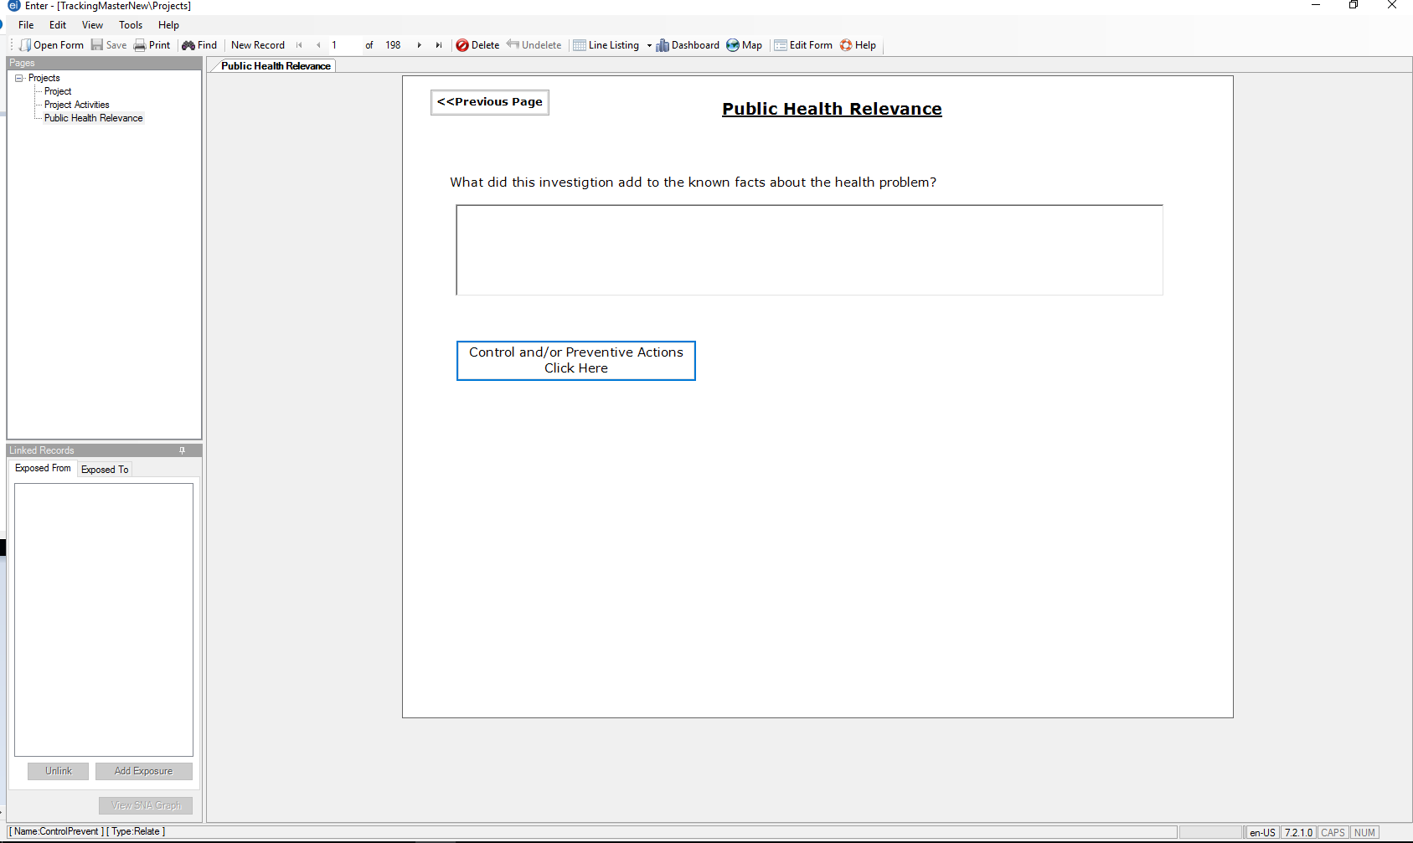

This third part of the main project tracking form concerns the relevance of the specific project in improving public health. It focuses on the type of actions taken in response to the findings of the project.

*What that this investigation add to the known facts about the health problem?*; This is a freeform text entry. Please state in your own words both the specific and general contribution of the findings of this project to public health of the population involved and if appropriate to the general public health.

*Control and/or Preventive Actions*: click this button to detail all control or preventive actions that resulted from this project. Some preventive actions are composed of synergistic individual actions. You will need to break down general preventive measures into these more detailed components. Complete an individual form for each component. For example, waterborne disease control would have several actions. One could educate the population to avoid contamination of their water supplies, educate the population to use only disinfected or boiled water for preparing food or drinking, provide chlorine disinfectant for their water source, repair or refurbish an existing degraded water system.

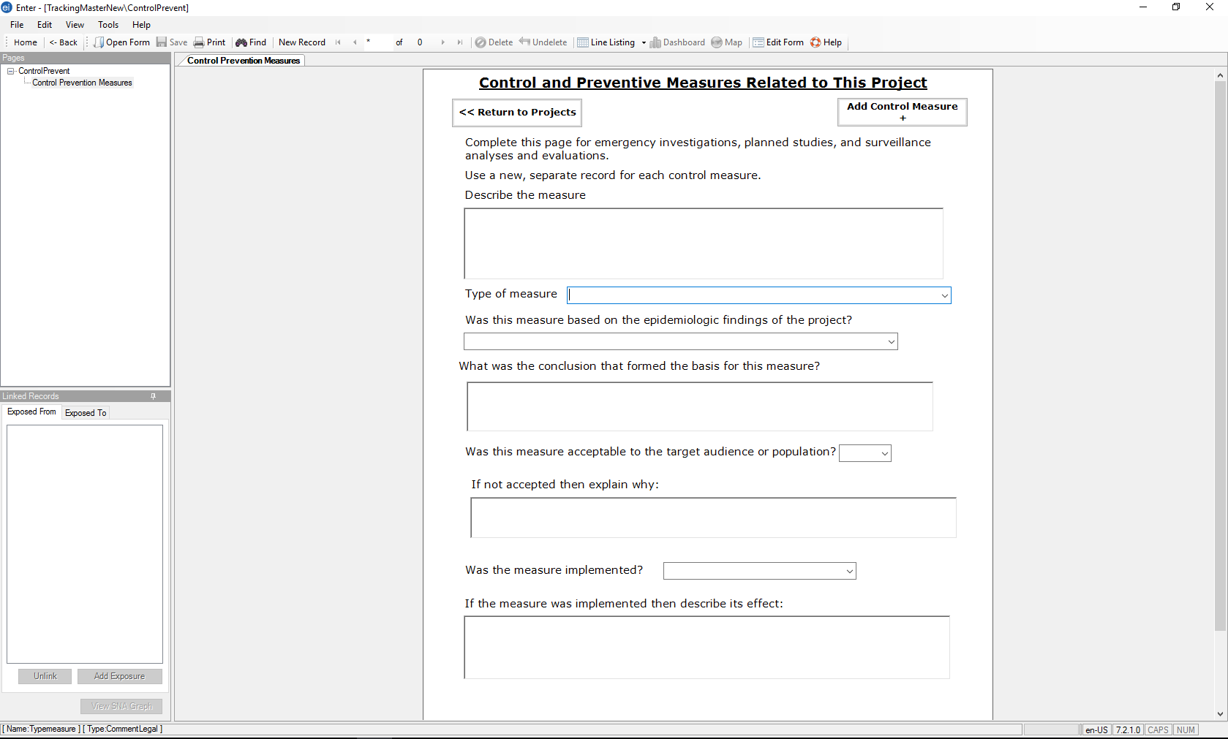

*Describe the measure*: This is a freeform text entry to give a description of the action taken.

*Type of measure*: Select the type of measure from the drop-down list. This is a detailed list organized into general categories by the leading digits of the code numbers. For example, code numbers beginning with 30 (300 to 307) involve control and prevention involving environmentally acquired agents. Code numbers beginning with 10 (100 to 108) involve zoonotic disease control. Appendix C provides a full list and description of these types of measures.

*Was the measure based on the epidemiologic findings of the project?*: Pick from the drop-down list. The choices 10, 11, and 12 describe three basic situations where the findings support the control measure. Choices 20 and 21 describe situations where the findings were not used to support the control measure.

*What was the conclusion that formed the basis for this measure?*: This is a freeform text entry. Write in your own words a conclusion of the investigation which formed the basis of the control measure. If the answer to the question was 20 or 21, type “No measure was based on this conclusion.”

*Was a measure acceptable to the target audience or population?*: Select **Yes** or **No**. Since many levels of acceptability, this is a relative judgment. You may elaborate on reasons for rejecting or partially rejecting the measure in the following question.

*If not accepted, then explain why*: This is a freeform text entry. You may elaborate here on the underlying reasons for rejecting or partially accepting the measure.

*Was the measure implemented?*: Select **Yes** or **No**.

*If the measure was implemented, then describe its effect*: This is a freeform text entry.

After finishing the data entry on a specific control and preventive measure if you need to enter another communication product, click “*Add control measure*”. When you finish adding all control/prevention measures click the “R*eturn to Projects*” button to return to the main project form.